QUESTION 2
- UML CLASS DIAGRAM
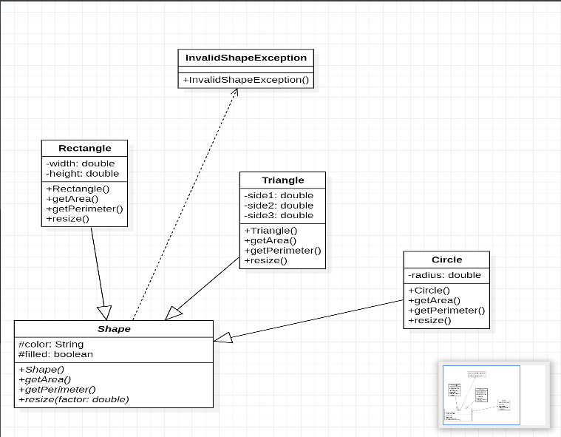
Figure 1: UML Class diagram showing the shape hierachy, inheritance relationships and dependency on InvalidShapeException

- Implementation
The system was implemented using Java. An abstract superclass named Shape was created with the protected attributes color and filled. Three concrete subclasses, namely Circle, Rectangle and Triangle, inherit from Shape and provide their own implementations of the abstract methods getArea(), getPerimeter() and resize().

- Exception Handling
A custom exception class named InvalidShapeException was created to handle invalid shape dimensions. The exception is thrown whenever a shape is created with invalid values, such as a non-positive radius or a triangle that violates the triangle inequality rule. The exception is demonstrated using a try-catch block in the driver program.

PART (E) :Dynamic Binding (Polymorphism) and Abstract Classes

Dynamic Binding (Polymorphism): Dynamic binding occurs when a method call is resolved at runtime based on the actual type of the object rather than the type of the reference variable. In this program, dynamic binding is demonstrated in the "printAreas(Shape[] shapes)" method through the statement:

System.out.println("Area = " + s.getArea());

Here s is declared as a Shape reference, but it may refer to a Circle, Rectangle or Triangle object. When the getArea() method is invoked, Java automatically executes the overridden version belonging to the actual object stored in s. For example, if s refers to a Circle object, the Circle implementation of getArea() is executed. This behavior allows a single method call to produce different results depending on the object's type, which is the essence of polymorphism.

Why the Shape Class is Declared Abstract

The Shape class is declared as an abstract class because it represents a general concept of a geometric shape and is not intended to be instantiated directly. It contains abstract methods such as getArea(), getPerimeter(), and resize(), whose implementations differ from one shape to another. Since there is no single formula that can be used to calculate the area or perimeter of every possible shape, these methods are declared abstract and must be implemented by each concrete subclass. The abstract class therefore serves as a blueprint that defines common properties and behaviors shared by all shapes while allowing subclasses to provide their own specific implementations.

Attempting to Create a Shape Object Directly

If an attempt is made to create an object using the statement:

new Shape();

The program will fail to compile because abstract classes cannot be instantiated. Java prevents the creation of objects from abstract classes since they may contain abstract methods that have no implementation. Instead, objects must be created from concrete subclasses such as Circle, Rectangle, or Triangle, which provide complete implementations of all inherited abstract methods.

